PS Lab 08

Sandeepa Y.V.P - IT24100834

Question 01

Question 02

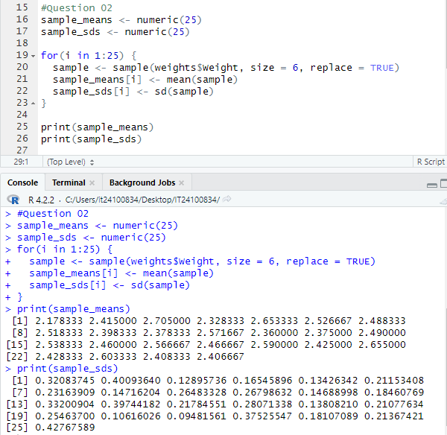

Question 03

